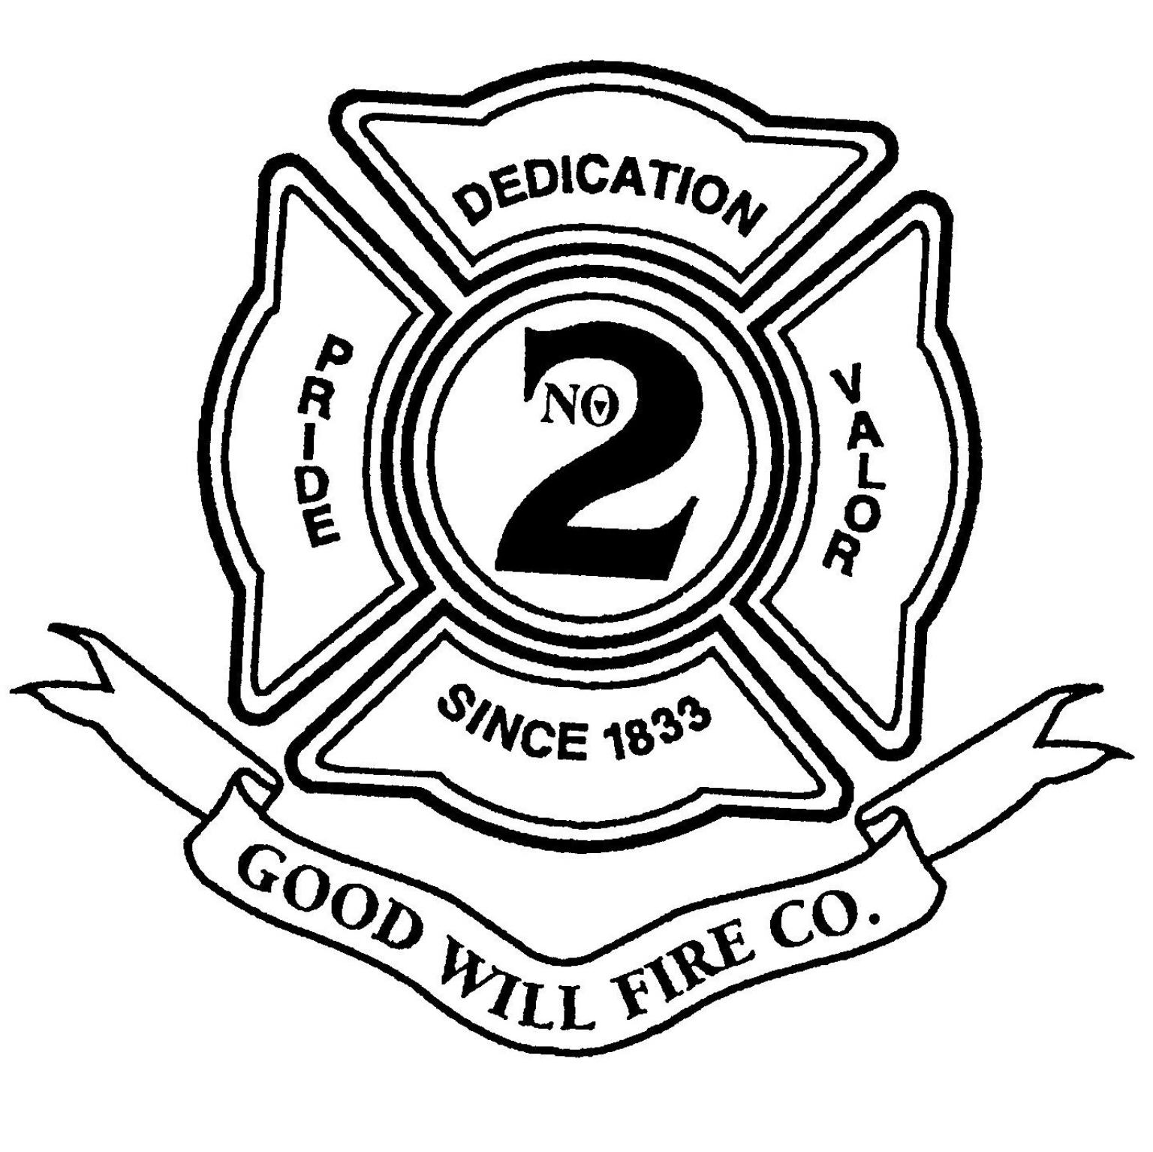 | Good Will Fire Company #2  36 East Gay Street  West Chester, PA 19380  610-431-4366 (Business/Voice mail)  610-431-6528 (Fax)  www.goodwillfireco.org  APPLICATION FOR MEMBERSHIP  Date: _________________

Parent’s Permission for Minors

We, the Parent(s)/guardian(s) do hereby give our consent for:

(Print name clearly)

to become a member of the Good Will Fire Company #2

Signed,

__________________________ _________________________
(Signature of Parent or Guardian/Date) (Signature of Applicant/Date)

_________________________________ ________________________________
(Print name of Parent or Guardian) (Print name of Applicant)

NOTE: This form must be accompanied by WORKING PAPERS, and the applicant, once voted in, must conform to all child labor laws.

PLEASE express any concerns by contacting the Captain by calling the above provided phone number.

